**Type Conversion and Casting**

**It’s really important which leads to errors later on if left now**

Basically when one type of data is assigned to another type of variable, an automatic type conversion will take place when,

both the variable and data to be assigned are compactable

the destination variable type is greater than data value type to be provided, like if destination variable is of float type and value is of int type

for example, if we are asking for float and provide integer

but

if we are asking for integer and provide float than it won’t work, gives error

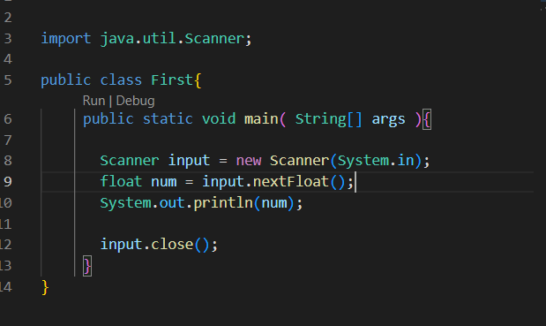

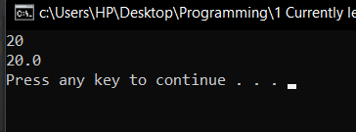

here we ask for float but provide int

but

that provided int was converted automaticly to float

**What if we needed to convert float to integer ?**

We use a term called **type casting**

**compressing a bigger type ( float ) in to smaller type ( int ) explicitely**



As now this gives an error

We can convert this in to integer as :

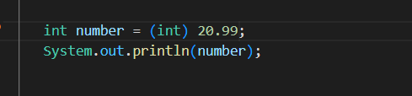

but it won’t round off, we will still get 20 not 21